Espie, C.A. (2011). An introduction to coping with insomnia and sleep problems. London: Robinson.

Prilog 1
Ček lista za provjeru nesanica

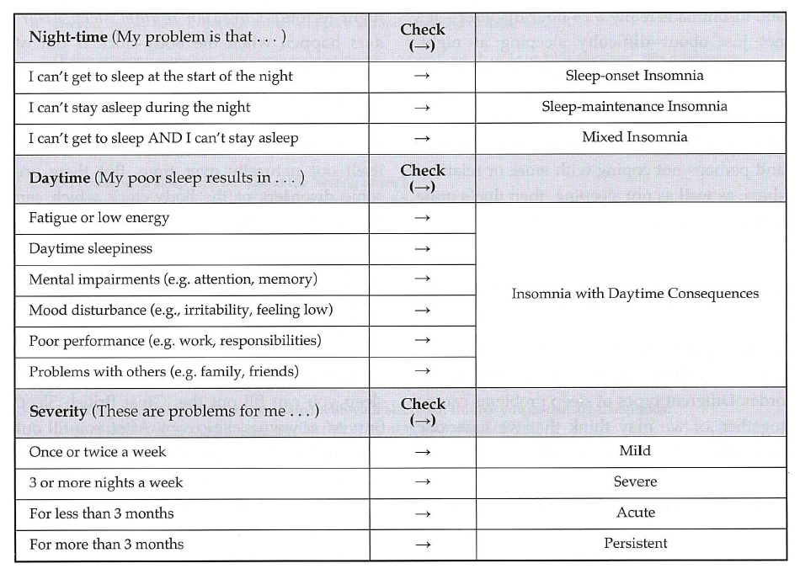

Prilog 2
Primjer dnevnika spavanja
